EM425 Assignment #6

Problem Statements

1. (Based on 6.34) Measurements of thermal conductivity,  (W/m-K), of silicon at various temperatures are:

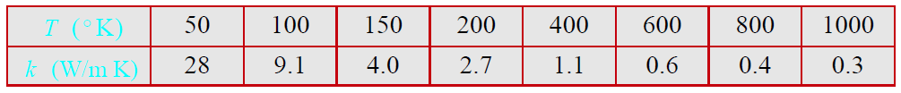

The data is to be fitted with a function of the form  Determine which of the nonlinear equations that are listed in Table 6-2 (also presented in Lecture 14) can best fit the data and determine its coefficients. Make a plot that shows the data points (asterisk marker) and the equation (solid line).

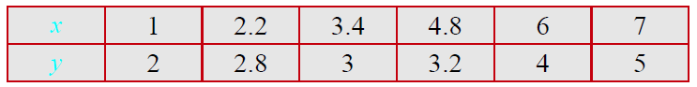2. (Based on 6.15) The following data is given:

In the space below, write the polynomial in Lagrange form that passes through the points.

3. (Based on 6.39) Values of enthalpy per unit mass,  of an equilibrium Argon plasma (Ar, Ar+, Ar++, Ar+++ ions and electrons) versus temperature are:

Write a script that uses interpolation to calculate  at temperatures ranging from 5000 K to 30000 K in increments of 500 K. The program should generate a plot that shows the interpolated points, and the data points from the table (use an asterisk marker).

a) For interpolation use Lagrange polynomials as demonstrated in Lecture 15.

b) For interpolation use MATLAB’s built-in tool interp1 with method=’spline’.

4. (Based on 8.1) Given the following data:

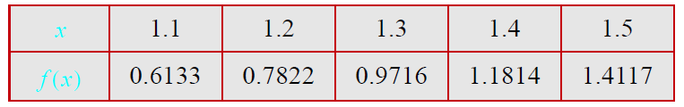Find the first derivative  at the point x = 1.3.

1. Use the three-point forward-difference formula.
2. Use the three point backward-difference formula.
3. Use the two-point centered difference formula.

5. (Based on 8.2) Given the following data:

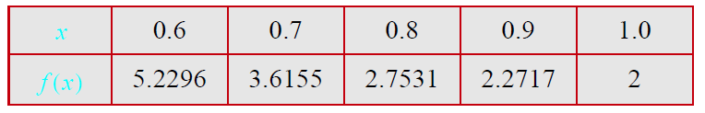

Find the second derivative  at the point x = 0.8.

1. Use the three-point forward difference formula.
2. Use the three-point backward difference formula.
3. Use the three-point central difference formula.

**Numerical Answers**

1. You should at least try all of the methods. I don’t want to spoil the fun but the best fit should look like the figure with a squared residual of 13.54.

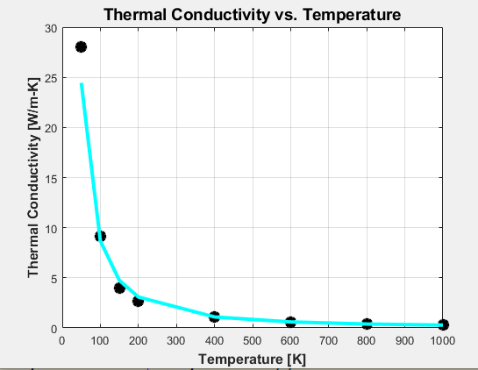

1. No numerical result.
2. 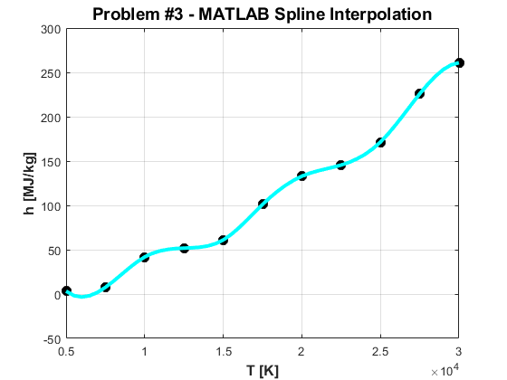No numerical result, but the plots are shown below:

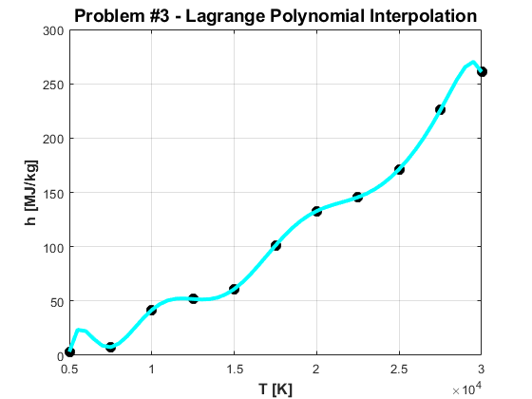

1. a) 1.9955; b) 1.9965; c) 1.9960
2. a) 20.97; b) 75.17; c) 38.10